COSC 412

Individual Project

By: Carter Lyons

**Preface**

This project aims to help online shoppers save money. They will enter a desired product into our search engine in order to find the site with the best deal. The engine will search popular sites like Amazon and Walmart.

**Table of Contents**

1. Introduction

1.1 Overview

1.2 Deliverables

1.3 References

2. Project Organization

2.1 Process Model

3. Managerial Process

3.1 Management Objectives and Priorities

3.2 Assumptions, Dependencies and Constraints

3.3 Risk Management

3.4 Monitoring and Controlling Mechanisms

4. Technical Process

4.1 Methods, Tools, and Techniques

4.2 Software Documentation

4.3 Project Support Functions

Introduction

1.1 Overview

1.2 Deliverables

* Design Review Mtg/ Tool Selection Review 10/28/2020
* Milestone Review 11/13/2020
* Final Presentation 12/01/2020

1.3 References

Project Organization

2. Project Organization

2.1 Process Model

* Agile

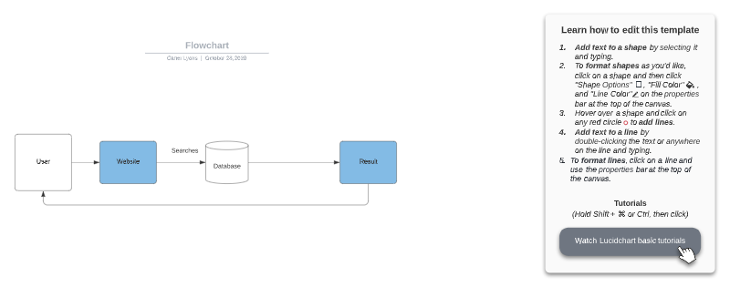

Managerial Process

3.1 Management Objectives and Priorities

* Stay on task and finish on time.

3.2 Assumptions, Dependencies and Constraints

* Constraints
  + Time

3.3 Risk Management

* Late start, makes for work crunch

3.4 Monitoring and Controlling Mechanisms

* Work on it daily.

Technical Process

4.1 Methods, Tools, and Techniques:

* Languages: HTML, CSS
* Database: Firebase
* Version Control: Git
* Web hosting: name.com
* Other: Amazon/Walmart APIs

4.2 Software Documentation

* Documentation exists to provide product functionality, combine project - related information and allow space to talk about any questions or concerns between stakeholders and developers.
* Documentation plan:
  + From the start to finish, the documentation goes over different aspects of the projects such as: high level requirements, test plans, test documentation, system documentation, installation guides, user manual and the final report. Below, we will expand over each part of the plan.
  + High level requirement:
    - Describes what the system should do and how it should do it.
  + Test plan:
    - How to test and what to test.
  + Test documentation:
    - Documentation of the testing itself.
  + System documentation
    - Class diagrams, Code comments.
  + Installation guides:
    - How to install it.
  + User manual
    - How to navigate and use it.
  + Final report:
    - Summary and conclusion.

4.3 Project Support Functions

* Testing:
  + Unit testing
  + Integration testing
  + Acceptance (final test)
* Configuration control
  + Program code changes
  + Requirements and design changes
* Quality assurance:
  + Make sure this works at the end